SUPPLY AND DEMAND
Student’s name
Institution name
Date

For each of the following situations, use supply and demand curves and a written description to explain the effect on the market, including the changes in equilibrium price and quantity and any initial shift in either supply or demand.
The effect on the market for new automobiles if auto manufacturers must pay an increase in wages for auto workers.
The price of labour would go up, since labour is an input or a cost to the company it would possibly cause things like layoffs or increased prices on goods in order to compensate for the rise in labour costs which would cause supply to shift to the left resulting in a higher equilibrium price
S2
S

P2
P1
P

D

Q

The effect on the market for air travel if high-speed rail at 400 km/hr. is introduced
Demand for air travel would drop causing a shift in demand to the left, a lower equilibrium price is created.
S

P1
P2
P

D

Q

The effect on the market for Netflix if prices for cable TV double.
If cable prices increase the demand for Netflix would increase causing demand to shift to the right and the equilibrium price to rise.

S

P2
P1
P

D2
D

Q

The effect on the market for wheat if farmers improve production efficiency with better equipment.
Productivity goes up, resulting in more output causing supply to shift to the right and the equilibrium price to go lower.
S2
S

P1
P
P2

D

Q

A written explanation to explain the difference between a change in demand and a change in quantity demanded.
A change in demand means change in demand due to the factors of demand other than price whereas a change in quantity demanded means change in the quantity purchased due to change in the price of a product. Change in demand will result in the shift in the demand curve whereas Change in quantity will result in movement of demand curve.
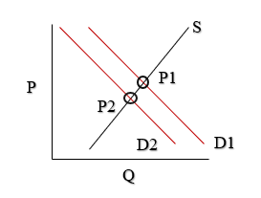

Problem created in the following market if the price is $11.00? How will it be corrected?
The price is too high. Less people will buy whatever is being offered whether it’s a product or a service. The price needs to be lowered to at least $10 in order to get the product/service selling or else nothing will be sold; they will have too much of whatever they’re offering and may have to reduce inputs such as labour or will have to sell at a discounted rate to get rid of backed up inventory.
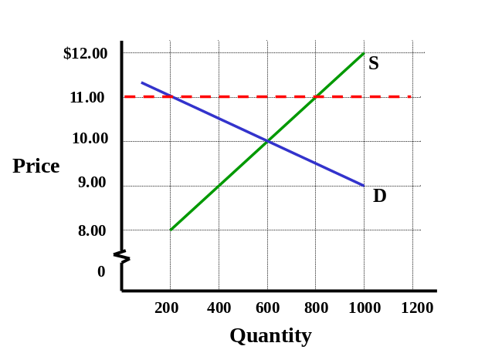

Describe an example of speculation in a market explain how the speculation affects market prices. Use a supply and demand diagram as part of your explanation.

An example of speculation is when consumers anticipate the price of goods or services to rise and they rush out and buy that good or service while the price is lower because they believe the price is going to increase when in fact the price wasn’t going to increase at all. Now because of this they just created an increased shift demand for the product or service, the price then increases resulting in a higher equilibrium price. Speculation takes resources at a low value and through time increases them to have higher value.

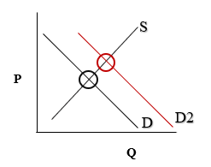

When a new product is introduced there is initially a small quantity being produced during the introduction stage? As consumers become more aware of the product the demand increases and as the product becomes more accepted in the market more competitors enter. Use a supply and demand diagram to explain what happens to price and quantity in a market when a new product becomes established and sales grow.
At first the price of the new product is high because there is initially only a small amount being produced but once the product becomes more popular and the market starts to become more saturated with more companies starting to manufacture the same product demand from the initial producer drops resulting in lower prices all around for the same product.

In the quick service food industry (which we know as the fast food industry) sales grow at an average rate of 8-10% per year. Although this rate of growth has slowed in recent years it is still growing as households have more income and spend less time cooking at home than ever before. The cost of food has also increased. And recently the minimum wage in Ontario has risen significantly affecting wages for a large percentage of employees in this industry. Analyze how these changes affect the market including how price and quantity will change generally. Use supply and demand diagrams as needed.

The price of labour would go up, since labour is an input or a cost to the company it would possibly cause things like layoffs or maybe the extras that used to be free will no longer be free in order to compensate for the rise in cost which would cause supply to shift to the left resulting in a higher equilibrium price. For example, when minimum wage increased McDonalds got rid of their Bacon McDouble and started offering only regular McDoubles and if you want bacon on it you have to now pay an extra $1.29 on top of the cost of the regular cost of the burger. Previously the Bacon McDouble was only $2.79 but in an effort to draw in more revenues because of the minimum wage increase McDonalds completely eliminated the Bacon McDouble and now you have to pay $2.29 for a regular one, plus $1.29 for each strip of bacon you add.
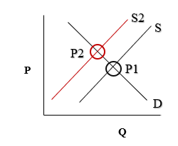
Pick a market of your choice.
Describe a factor in this market that has caused a shift in demand and explain the impact on the market using a supply and demand diagram.

The market I have chosen is the coffee market. A factor that would cause a shift in demand in the coffee market would be if tea had a significant price drop. Since most people consider tea a coffee substitute more people would then drink tea since it is became cheaper causing demand to decrease. This results in a lower equilibrium price and demand would shift to the left on the supply and demand curve.

S

P1
P
P2

D2
D1

Q

Describe something in this market that has caused a shift in supply and explain the impact on the market using a supply and demand diagram.
A factor that would cause a shift in supply in the coffee market would be if a bug came and destroyed half of the coffee bean crops. Half of the supply is now gone causing supply to decrease. This results in a higher equilibrium price and supply would shift to the left on the curve.

S2
S1

P2
P
P1

D

Q

